BLADE ELEMENT THEORY (Introdução ao Projeto Aeronáutico, Prof. Edison da Rosa – módulo 3 – capítulo 8.5)

A propeller blade Works as a plane wing generating lift and drag. Each blade section is considered as working independantly, with no radial flux.

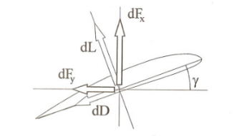

dFx generates thrust and dFy generates resistance torque. Considering a blade element of width db, the forces generated are d Land dD.



From here, aerodynamics are used to discover d Land dD

   

C = chord

Integrating for the total Thrust and Torque. (T = Thrust, M = Torque)

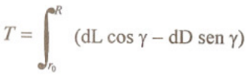 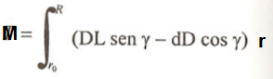

Extra steps are used such as db = bdr (b=1 -> db = dr)

And **γ** = arctg(v/**ω**.r)*******, with v being the aircraft’s velocity forward and **ω**.r being the tangencial velocity of the blade element

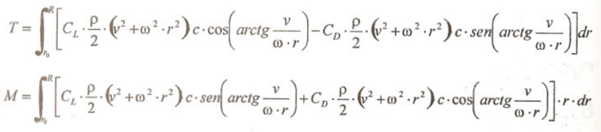

*******: for studies that consider the propeller stationary, consider not using this step

Main factors to be studied on the integral:

* Cl and Cd of the airfoil, wich vary based on the velocity experienced by the airfoil combined with it’s angle of attack and chord. The behaviour of this factor can change based on the diameter, aircraft velocity and pitch values chosen. It is essential to determine how these values will behave with varying distances from the center of rotation.
* V (aircraft velocity)
* **ω**
* C (airfoil chord)

ANOTHER EXPLANATION (ESTUDO E DIMENSIONAMENTO DE HÉLICES PARA PROPULSÃO AERONÁUTICA)

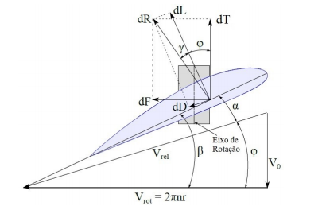

dT is lift and dF is Drag

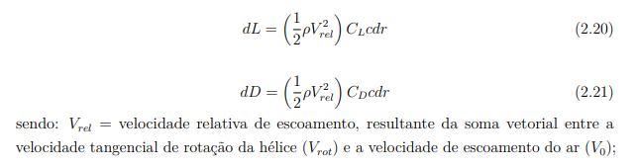

Being Vrel = relative velocity of flow, resulting from the vectorial sum of tangencial velocity and aircraft velocity.

 => 



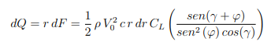

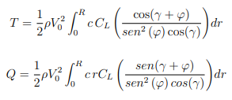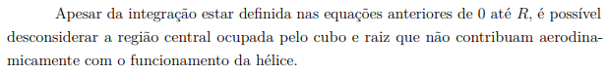

ANOTHER EXPLANATION FOR BLADE ELEMENT THEORY

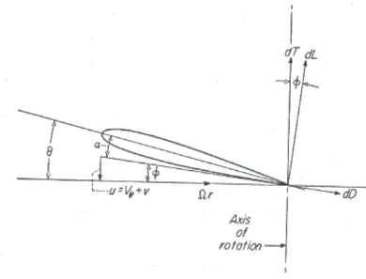









Simplification follows for a theory that predits a helicopter hovering (a parallel for no aircraft velocity forwards)

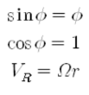

A formula that determines (imposes) how the lift coefficient is going to change based on it’s angle of attack follows

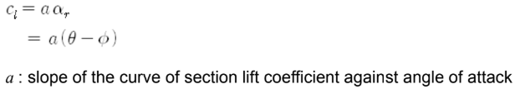

A formula that determines (imposes) how the angles change based on it’s distance from the center of rotation follows

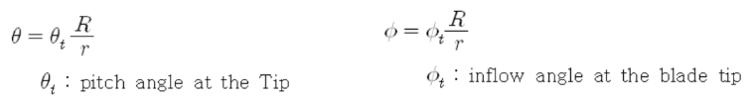

Process of integration follows

